Watertown Recreation Swim Team
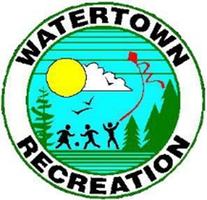
Mission Statement

- Provide a safe practice for 5 to 18 year olds in a competitive swim team and have children develop bonding and social skills while having fun.

- Adhere to safety and conduct standards of the Town of Watertown and its facilities.

- Learn how to compete in a competitive setting
- Work on respect of the coaches
- Work on respect of officials
- Work on respect of opponents
- Work on respect of the individual and each
Other

- Establish a legacy by setting goals to have the participants get involved and stay involved.

- Work in conjunction with the Yankee Swim League and the USA Swim Organization and abide by their guidelines.

Watertown Parks and Recreation Department, 61 Echo Lake Road, Watertown, CT 06795
860.945.5246

